**CRICKET PLAYER PERFORMANCE MONITORING SYSTEM / CPP**

**HIGH LEVEL DESIGN DOCUMENT**

**Version 1.0**

**04/04/2019**



Contents

Abbreviations 3

1. Introduction 4

**2.** **Current System** 6

2.1 Functional Description 6

2.2 User Community Description 6

2.3 Technical Architecture 6

3 Goals, Objectives, and Rationale for New or Significantly Modified System 8

Project Purpose 8

3.1 System Goals and Objectives 8

3.2 Proposed System 8

**4 Factors Influencing Technical Design** 9

4.1 Relevant Standards 9

4.2 Assumptions and Dependencies 9

4.3 Constraints 9

4.4 Design Goals 9

**5.** **Proposed System** 10

5.1 High-Level Operational Requirements and Characteristics 10

5.5 High-Level Architecture 12

5.5.1 Authentication 16

5.5.2 Authorization 16

**6.** **Analysis of the Proposed System** 17

6.1 Impact Analysis 17

6.2 Risks 17

6.3 Issues to Resolve 17

6.4 Critical Success Factors for Remainder of Project 18

# 

Abbreviations

|  |  |
| --- | --- |
| **Acronym** | **Phrase** |
| dim | Dimension |
| ODI | One Day International |
| CPP | Cricket Player Performa |

## Introduction

The project “Cricket Players Performance System” consists of given raw data for all players of ODI, T20 and Test that conveys important information such as matches played, runs scored, batting innings etc. The purpose of this project is to analyze the performance of players considering various parameters. It uses parameters such as batting average, bowling average, runs scored to find the top and bottom players.

This Document outlines the High Level Design for the PLP “Cricket Players Performance System”. The project aims to design the data ware house, reports and queries related to the performance of cricket players. It contains Design of Dimensional model, Schema structure, Reports and related high level details.

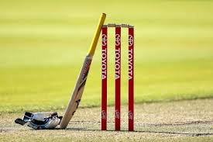

## **Current System**

To monitor player performance, various data such as batting average, bowling average, runs scored etc. is recorded for all players in excel sheets. As the performance parameters differ for different match formats such as ODI, T20 and Test; the analysis becomes difficult as there is a huge amount of data to analyze. Also, due to lack of functionalities in MS-Excel many desired functions can’t be performed and it becomes difficult to represent data pictorially.

Using AbInitio to do the same, the analysis becomes easy as data can be collected in separate data marts for different match formats. Also, by using reporting tools such as QlikView and QlikSense, the reports can be presented pictorially which makes it easier for the user to compare, analyze the results and draw the required conclusions.

### 2.1 Functional Description

* A **file system** can be thought of as an index or database containing the physical location of every piece of data on the hard drive or another storage device. The data is usually organized in folders called directories, which can contain other folders and files.
* File system controls how data is stored and retrieved.
* File systems allocate space in a granular manner, usually multiple physical units on the device. The file system is responsible for organizing fields and directories, and keeping track of which areas of the media belong to which file and which are not being used.
* File systems specify conventions for naming files, including the maximum number of characters in a name, which characters can be used and, in some systems, how long the file name suffix can be. In many file systems, file names are not case sensitive.

### 2.2 User Community Description

The project is useful for organizations such as BCCI who intend to analyze the players’ performance to facilitate their participation in various series of matches. Also, it is useful for people participating in the auction of events like IPL to be sure that they bid for the best of players.

### 2.3 Technical Architecture

* The various data is collected from various sources and merged into a single excel sheet.
* This data is then manually analyzed by a person using the given excel functionalities to produce the required results.

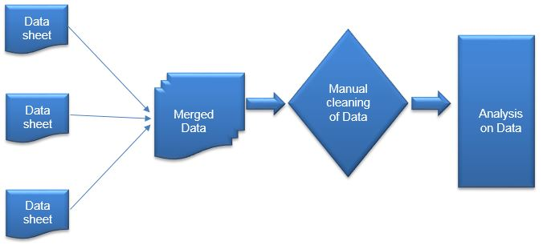

## **3 Goals, Objectives, and Rationale for New or Significantly Modified System**

### Project Purpose

This project is aimed at developing Cricket Players Performance System (CPPS). The system will be used to check the performance of the cricketers of different countries in various types of international matches and to make decision support with the help of universe.

### 3.1 System Goals and Objectives

The main goals and objective of the system is to provide the authorities with a solution for performance analysis which allows matches to be recorded live, with statistical information recorded for review in real-time thus providing information for pre-game and in-game decision making.

### 3.2 Proposed System

The proposed system is first taking the player names from the user, reformatting them by trimming the spaces and then taking the unique values to make a new Player ID. Then the players of the other match types are joined with it first according to player id and then again with country id to get the final output in order to generate required reports.

**Loading data to data warehouse**

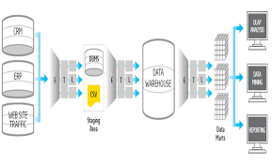

## **4 Factors Influencing Technical Design**

### 4.1 Relevant Standards

* The standard formulas and parameters used to generate data for comparison of players’ performance are as per worldwide cricket standards.
* All ETL standards are taken into considerations.

### 4.2 Assumptions and Dependencies

* The schema structure is designed considering the fact that a player can have a separate Player ID for the different match formats he has played for.
* To identify the match format for the player, a dimension table called match_dim containing match category is used.

### 4.3 Constraints

The project has certain limitations such as:

* If new data is added, the data has to be cleaned before loading it into the data warehouse and for this purpose, the person adding the data needs to have AbInitio installed on the system.
* If the end user wishes to verify or change the formula for batting average, he must have AbInitio installed in his or her system.
* To analyze the reports and apply certain filters to the data, the end user requires access to the paid version of QlikView and QlikSense.

### 4.4 Design Goals

* The schema is designed in such a manner that it is easily understood by the end user.
* A composite key is used to link the dimension and fact tables so that there is no redundant or duplicate data.
* It covers all parameters required for the analysis of performance of players in all formats.
* The reports generated are self-explanatory and can be easily comprehended by the end user.

## **Proposed System**

The CRICKET project is made to deliver the reports which include statistics about batting, bowling and fielding in all three match type that is TEST, T20 and ODI

OPERATIONAL REQUIREMENTS:

* Reports are easily understandable and according to that decisions can be made based on the purpose of the user.
* Tools like Ab Initio is used for data cleansing and QlikVIEW and QlikSENSE are used for reports creation.
* Performance will be better if there will be no data redundancy and no data corruptancy.
* In order to get best results possible, it is advised to update data on regular basis.

### 5.1 High-Level Operational Requirements and Characteristics

The Project is based on a Snow-Flake Schema which has three fact tables for all match type that is TEST, T20 and ODI and three dimension tables as Player, Country and Match Category.

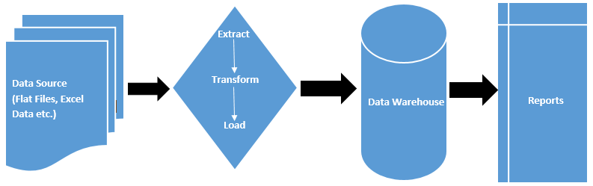

5.1.1 Sample Reports

1. Top 3 Batsmen-Countrywise

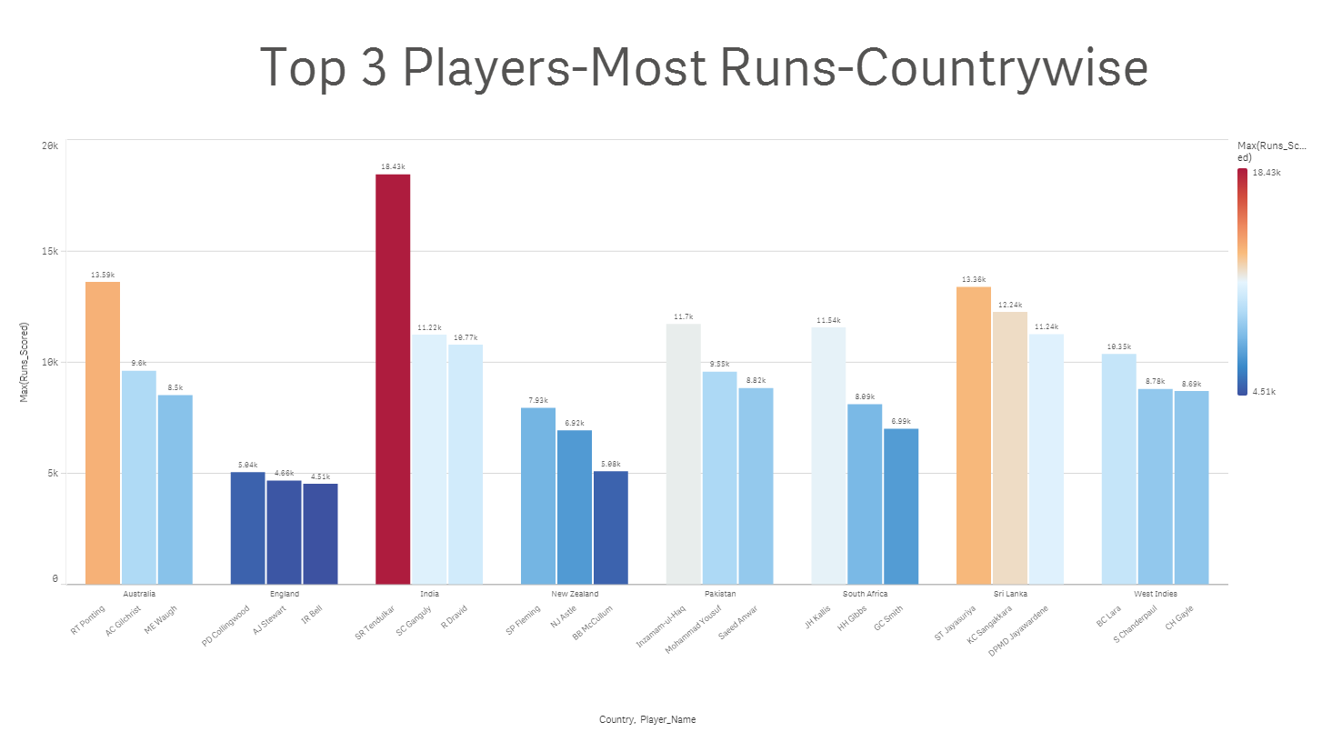

1. Max 100s in ODI

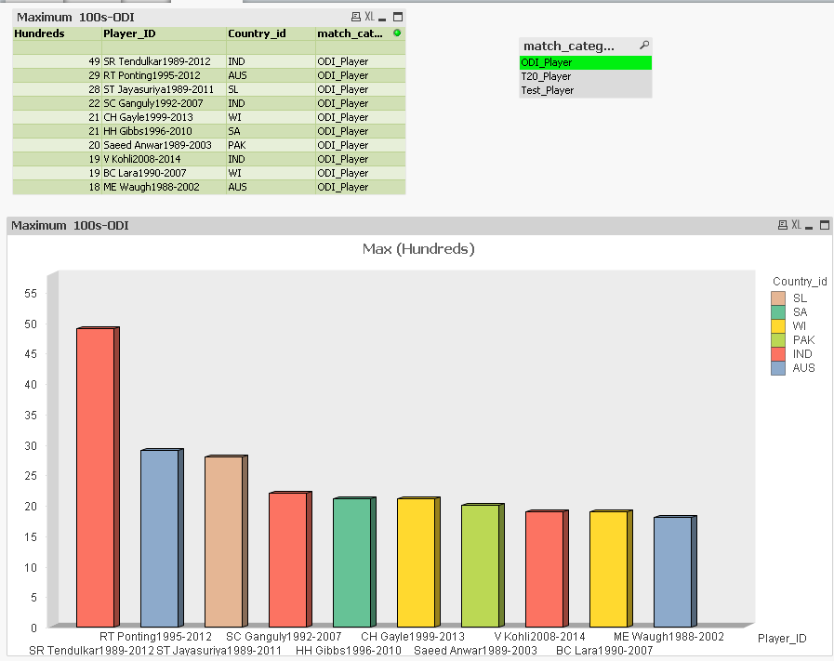

1. Top 10 Players-Not Outs

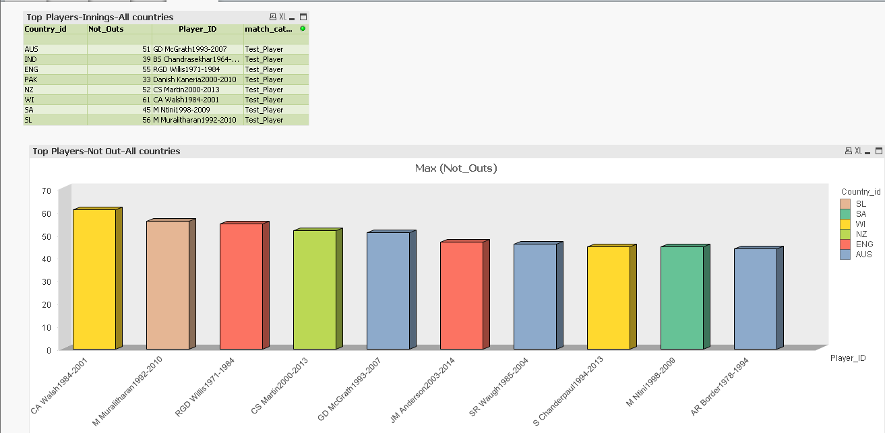

#### User Community Description

* The project is used by data modelers.
* The data is cleansed and analyzed by ETL developers.
* The end users are organizations such as BCCI who intend to analyze the players’ performance to facilitate their participation in various series of matches. Also, it is useful for people participating in the auction of events like IPL to be sure that they bid for the best of players.

#### 5.3 Non-Functional Requirements

* Person must be familiar with reading of reports, he should know how to use data from reports to take the best decision possible.
* Person accessing reports must have access to the paid version of QlikVIEW and QlikSENSE for optimal results and using filters in the reports

##### 5.4 Security and Privacy Considerations

The CRICKET record contains sensitive information that must be protected from security vulnerabilities and exploits as data manipulation can lead to wrong reports and decisions. All work should be done on a continual basis to identify and remediate those vulnerabilities using a variety of tools that are available.

### 

### 5.5 High-Level Architecture

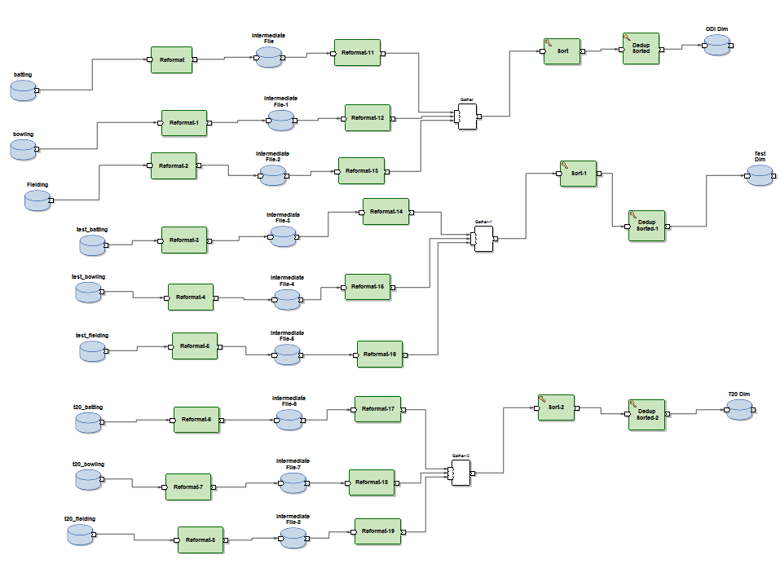

#### 5.5.1 Application Architecture

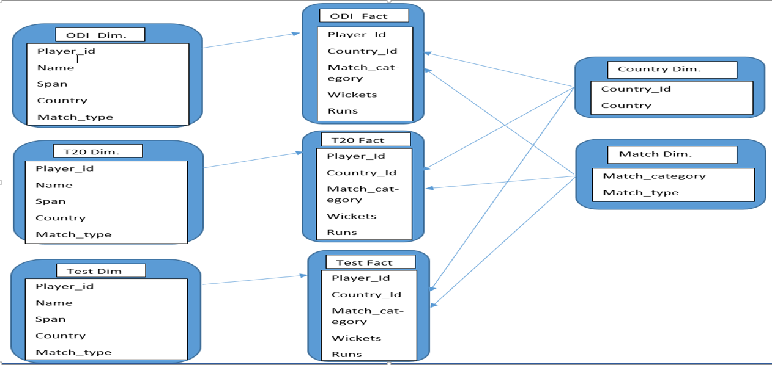

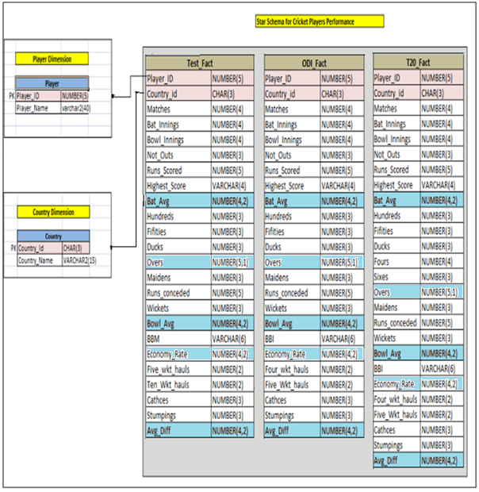

#### 5.5.2 Security and Privacy Architecture

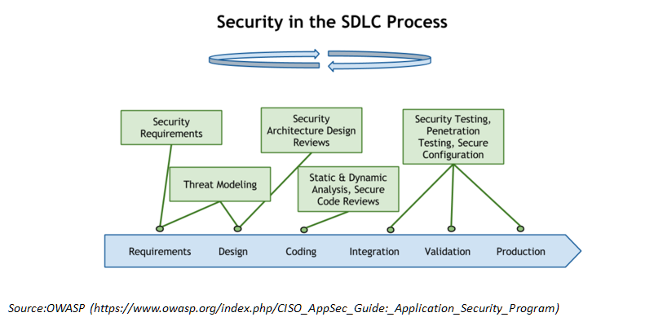

The security of data should be maintained and following things should be done to prevent any breach

1. Isolate sheets—maintain an accurate inventory of all data deployed across the enterprise and identify all sensitive data residing on those sheets
2. Eliminate vulnerabilities—continually assess, identify and remediate vulnerabilities that expose the data sheets.
3. Changes must be updated---Any changes which are reflected in the data must be informed to the database administrator
4. Strong password protection---Strong passwords will restrict any user to open the sheet in any mode. Only verified users can access the data.
5. Respond to suspicious behavior—Alert and respond to any abnormal or suspicious behavior in real time to minimize risk of attack.
6. Database activity monitoring (DAM) tools will also aid in the process of reducing vulnerabilities by providing visibility in real time into all database activity. Such tools collect data, aggregate it and analyze the data to look for activities that are in violation of security policy or that indicate anomalies have occurred. To ensure that threats are minimized and the requirements of regulations are being complied with, DAM tools should be used to identify anomalous activities such as privileged users viewing sensitive data, altering log records, making unauthorized configuration changes or creating new accounts with super user privileges. They can compare activities performed with those authorized by change requests.

### 5.5.2.1 Authentication

Authentication is the process of confirming that a user logs in only in accordance with the rights to perform the activities he is authorized to perform. User authentication can be performed at operating system level or database level itself. The security can be managed from outside the db2 database system. Here are some type of security authentication process:

* Based on Operating System authentications.
* Lightweight Directory Access Protocol (LDAP)

For Authentication, it requires two different credentials, those are user id or username, and password.

### 5.5.2.2 Authorization

Authorization is a process managed by the DB2 Database manager. The manager obtains information about the current authenticated user, that indicates which database operation the user can perform or access.

Here are different ways of permissions available for authorization:

**Primary permission**: Grants the authorization ID directly.

**Secondary permission**: Grants to the groups and roles if the user is a member **Public permission**: Grants to all users publicly.

**Context-sensitive permission**: Grants to the trusted context role.

Authorization can be given to users based on the categories below:

* System-level authorization
* System administrator [SYSADM]

## **Analysis of the Proposed System**

### The Cricket Players Performance (CPP) System engages in providing the overall analysis of the player’s performance in different roles: Batsmen, Bowlers and Fielders, across all the three formats of Cricket: ODI, T20 and Test.

### Impact Analysis

### While developing the Cricket Players Performance (CPP) System, more emphasis was laid to make it easier for International Cricket Council (ICC) and the domestic Cricket organizations such as BCCI, Cricket Australia (CA), England and Wales Cricket Board (ECB), etc. to extract the detailed analytical reports of player’s performance internationally and domestically respectively, across the three formats of Cricket namely, One-day International (ODI), Twenty-20 International (T20I) and Test.

#### Operational Impacts

#### CPP System simplifies the data and produces the clean data, which are called as Fact Tables. These Fact Tables are combination of player’s data as different specialist roles such as Batsman, Bowlers and Fielders, as one separate table for each of the formats, making it easier to analyze the top performers across formats such as batsmen with highest run scored, batsmen with most runs scored, bowlers with most wickets, bowlers with best economy rate, etc.

#### Organizational Impacts

#### CPP System makes it easier for ICC and the respective domestic cricket boards of the top 8 countries to get the detailed analysis report of the players internationally and domestically. It also helps in determining which countries have performed better overall, on the basis of the reports generated. The analysis can be performed on active domestic players as well, which may serve as an important basis for the selection criteria for the national cricket team.

### Risks

No Risks Involved

### Issues to Resolve

### The CPP System may need to modify the project for the detailed analysis of domestic players of respective countries, as it is developed in accordance with the data provided by the International Cricket Council only. Apart from this, the risk of having different names of same player in same format in different specialist role, needs to be resolved for T20 and Test Cricket format.

### Critical Success Factors for Remainder of Project

Additional Reports like top players with maximum number of sixes, fours, catches, stumping, etc. and overall performance score of the players in terms of respective format can be generated.